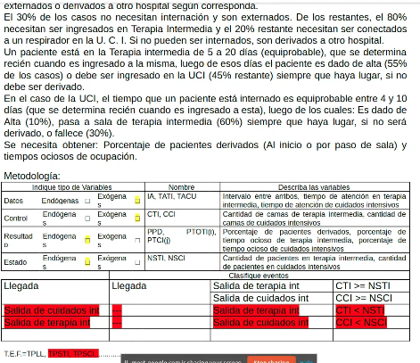

Metodología : Δt At ...... EaE

| Indique tipo de Variables | | | | | | Nombre | | Describa las variables | |
| --- | --- | --- | --- | --- | --- | --- | --- | --- | --- |
| Datos | Endógenas | □ | Exógenas | | □ | IA, TATI, TACU | |  | |
| Control | Endógenas | □ | Exógenas | | □ | CTI, CCI | |  | |
| Resultado | Endógenas | □ | Exógenas | | □ | PPD, PTOTI(i), PTOCI(j) | |  | |
| Estado | Endógenas | □ | Exógenas | | □ | NSTI(i), NSCI(j) | |  | |
|  | | | | Clasifique eventos | | | | | |
| Eventos | | | | EFNC | | | EFC | | Condición |
| Llegada | | | | Llegada | | | SalidaCI[i]  SalidaTI[j] | | CCI[i]>=NSCI[i]  CTI[j]>=NSTI[j] |
| SalidaCI[i] | | | | ---- | | | SalidaCI[i] | | CCI[i]<NSCI[i] |
| SalidaTI[j] | | | | ---- | | | SalidaTI[j] | | CTI[j]<NSTI[j] |
|  | | | |  | | |  | |  |

T.E.F.= TPLL, TPSCI[i], TPSTI[j]

(Había que usar vectores para las variables de estado y TEI)